Name: Class:
Introduction
Photosynthesis allows life on Earth to exist. This endothermic process takes place in chloroplasts, which contain the green pigment called chlorophyll. Sunlight provides the energy for the process, during which light energy is converted to chemical energy.

No. | Question | Answer
 | What four things are essential for photosynthesis to occur?
 | Write a balanced chemical equation for photosynthesis.
 | In what types of organisms does photosynthesis occur?
 | What effect does photosynthesis have on the level of carbon dioxide in the atmosphere?
 | What is the name of the photosynthetic organisms in the sea that produce most of our oxygen supply?

Use the graphs below to answer the next five questions.
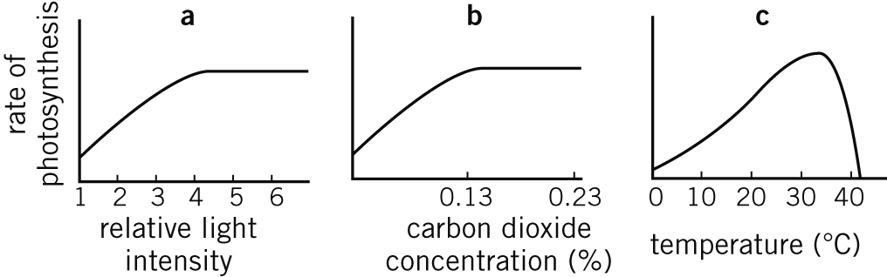

No. | Question | Answer
 | Write a hypothesis to explain why photosynthesis stops at temperatures over 40°C.
 | How would the rate of photosynthesis change if the concentration of CO₂ was increased from 0.2% to 0.4%?
 | Based on the graphs shown, what three conditions allow for the maximum rate of photosynthesis?
 | How would the rate of photosynthesis in a plant in a Broome winter compare to the rate of photosynthesis of a similar plant in an Albany (WA) winter?
 | The atmospheric concentration of CO₂ increases during the night and decreases during the day. Explain why this occurs.

On the axes below, plot the following data, which shows how the photosynthetic rate in a corn plant changes with changing CO₂ availability (in μmol of CO₂ per mol of gas). Draw a smooth curve through the points.
CO₂ (µmol mol^{–1}) | Photosynthesis (% of maximum)
30 | 0
120 | 33
260 | 54
380 | 66
530 | 73
680 | 77
840 | 80
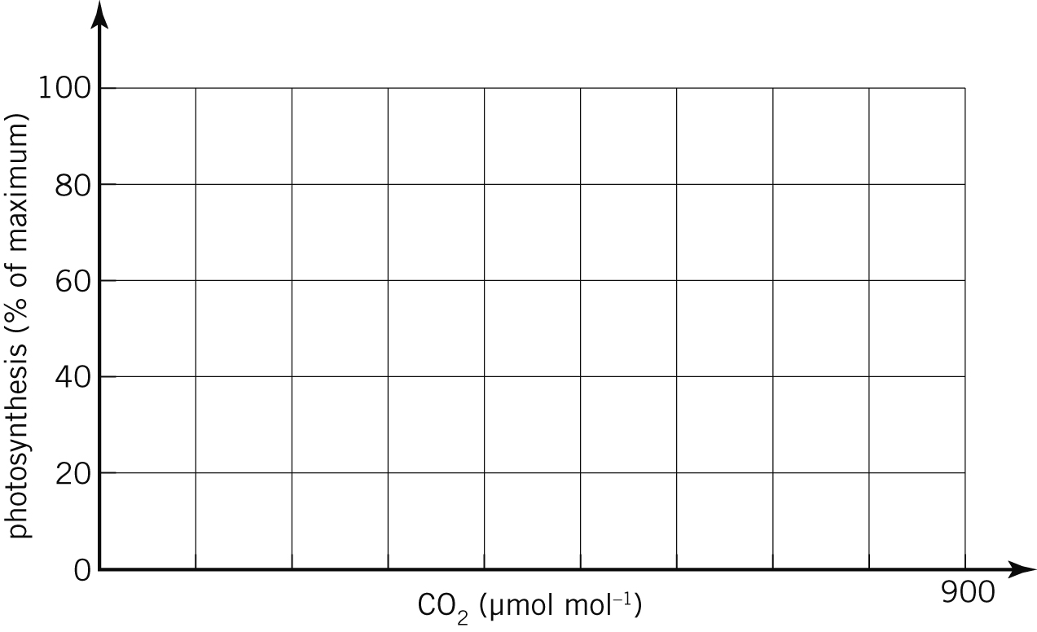

No. | Question | Answer
 | What would the photosynthetic rate be when the concentration of CO₂ was 200 µmol mol^{–1}?
 | What is the concentration of CO₂ when the photosynthetic rate is 60%?
 | If 300 µmol of CO₂ was consumed in photosynthesis, what mass of oxygen would be produced?
 | Why does the graph appear to be levelling off?

